**What is current role & responsibilities?**

Onsite Coordinator, Tech Lead.

* Providing project estimates.
* Development using the applicable technologies and following **Agile methodology**.
* Preparing Unit Test Plans and Test Automation using **JUnit** test framework.
* Configuration Management using configuration management with SVN and using SmartSVN client tool.
* Implementing **DevOps** related automations using tools like JUnit, Jenkins etc.
* **Doing POCs** (Proof of concepts) for different proposals using client recommended Open-Source technologies.
* Successful initiation, planning, execution, control and completion of the project by guiding team members on technical aspects.
* Conducting reviews of code, and technical documents/artifacts.
* Lead the customer interface for the project on an everyday basis, proactively addressing any issues before they are escalated.
* **Leading** project development and maintenance activities.

**Achievements:**

* **Automations for PDTS -** Build process, Test Automation, Continuous Integration and Automated Deployment using Jenkins, LoginAs Function, Log Rotation tool.

**Exclude classes with Maven WAR plug-in:**

To exclude some set of classes from the final WAR file. Do it like this:

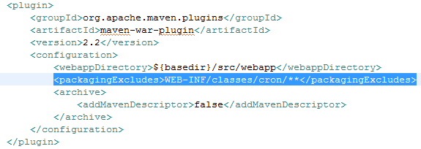

**Run a class as a part of Maven Build process:**

Do it like this:

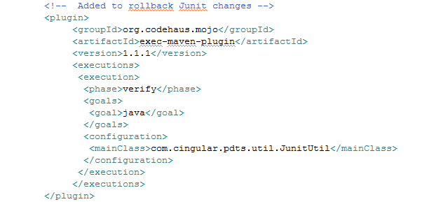

**PDTS Load Balancing request details:**

* Provide the load balancer requirements as a part of **LB Decision Process Questionnaire template**.
  + Any external access requirements by a third party? (Internet, FriendsNet, Business Partner Link, Remote Call Center, etc.)
  + Are global server load balancing services required? (for e.g. hot-hot, hot-warm, hot-cold, etc.)
  + App info
  + Content rules:
    - Web server info like type (Ex. Apache)
    - URL
    - Load Distribution Algorithm [we had used **Round Robin** (AKA Cyclic)]
    - Sticky Client Method? AKA "Persistence" [we had used **Cookie** (HTTP)]
      * Other options were: IP Address, SSL (HTTPS).

Once connected, if a client should remain associated with the same server for a period of time, what will be the basis for that persistence? Available strategies for persistence will vary by data center and load balancer type.

* + - Keep-Alive Path (If keep alive type is one of the HTTP types, enter the path the LB can pull to make sure the service is up) ex. /pdts/index.jsp
    - Server details (IPs & Hostnames)
    - Capacity metrics
      * Estimated connections / sec during busy-hour Ex. 9
      * Estimated simultaneous active sessions Ex. 2000
      * Estimated bandwidth requirements per connection Ex. 50000 (In bytes / connection. For an HTTP app, the average page/element size. Again, content-rule specific.)
      * Forecasted growth of traffic metrics over next 6 months Ex.10%

**PDTS Overview:**

Personnel Development Tracking System (PDTS) was designed to standardize Discussion and Discipline coaching/interactions. It also provides a better experience for managers and employees by improving back office communications. Over 10k AT&T Mobility managers use PDTS (with a standardized and HR/Legal approved way) to capture coaching discussions and performance topics. Identifying, sharing , and resolving coaching issues across groups using a large notification and approval structure is now a critical process within many of the Business Units using PDTS. With extensive reporting options, PDTS also serves as an effective tool to insulate AT&T resources against legal claims made in regards to past performance and specific individual/supervisor responsibility.

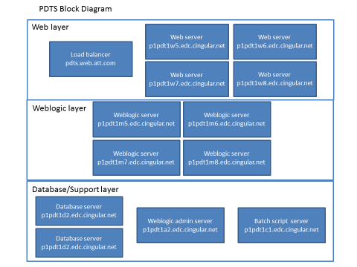

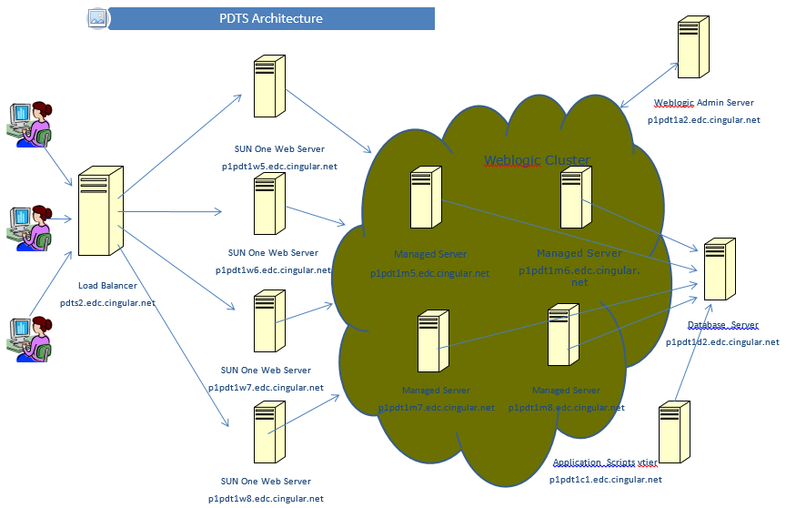

**SRS Overview:**

SRS-PAR is a **customer service reporting tool**. This application is developed in response to the Personal Accountability Reporting initiative, and is intended to provide individual customer service agents daily feedback on their performance meeting standard call center metrics.

It helps call center personnel to monitor call handling performance and quality statistics. It also provides call center managers, directors, and executive managers with a range of team-level to enterprise-level call handling metrics reports.

It generates various reports based on the data gathered from different ACD and ICM platforms. Some of the reports include Application stats, Performance stats, Login events, Agent audits (repeat call stats, CTN stats, Clarify interactions) and PAR reports for reps and management.

SRS-PAR Hierarchy is determined

* Payroll system, eLink for internal/company owned call centers
* Via file feeds for vendor call centers.

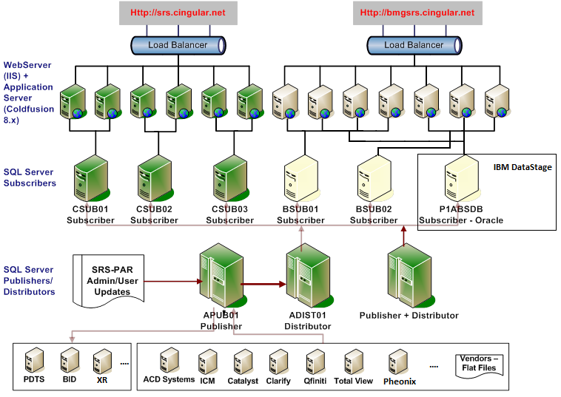

**Web Server vs App Server:**